1. Implement Parallel Reduction using Min, Max, Sum and Average operations(using OpenMp)
2. Write a CUDA program that, given an N-element vector, find-
   1. The maximum element in the vector
   2. The standard deviation of the values in the vector

Test for input N and generate a randomized vector V of length N (N should be large). The program should generate output as the two computed maximum values as well as the time taken to find each value.

1. Write a CUDA program that, given an N-element vector, find-
   1. The minimum element in the vector
   2. The arithmetic mean of the vector

Test for input N and generate a randomized vector V of length N (N should be large). The program should generate output as the two computed maximum values as well as the time taken to find each value.

1. **Vector and Matrix Operations-**Design parallel algorithm to

* Add two large vectors
* Multiply two N × N arrays using n2 processors

1. **Vector and Matrix Operations-**Design parallel algorithm to

* Multiply Vector and Matrix
* Multiply two N × N arrays using n2 processors

1. **Vector and Matrix Operations-**Design parallel algorithm to

* Add two large vectors
* Multiply Vector and Matrix

1. **Parallel Sorting Algorithms-** For Bubble Sort and Merger Sort, based on existing sequential algorithms, design and implement parallel algorithm utilizing all resources available.
2. **Parallel Search Algorithm-**Design and implement parallel algorithm utilizing all resources available. For

**Binary Search for Sorted Array**

1. Solve 8-puzzle problem using A* algorithm. Assume any initial configuration and define goal configuration clearly.
2. Implement goal stack planning for the following configurations from the blocks world,

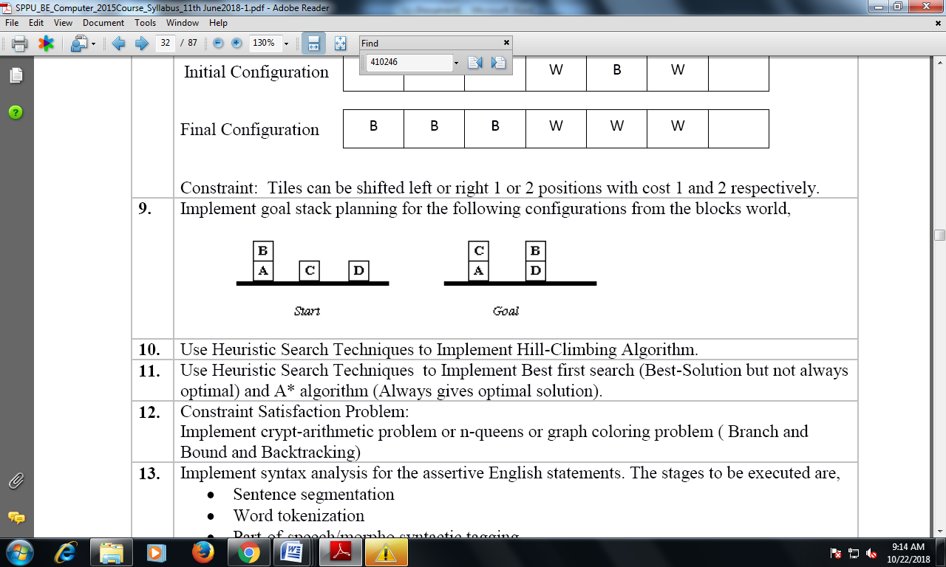

1. Use Heuristic Search Techniques to Implement Hill-Climbing Algorithm(8 queens).
2. Use Heuristic Search Techniques to Implement Best first search (Best-Solution but not always optimal) and A* algorithm (Always gives optimal solution).
3. Constraint Satisfaction Problem: Implement crypt-arithmetic problem.
4. Download the Iris flower dataset or any other dataset into a DataFrame. Use Python/R and Perform following –

* How many features are there and what are their types (e.g., numeric, nominal)?
* Compute and display summary statistics for each feature available in the dataset. (eg. minimum value, maximum value, mean, range, standard deviation, variance and percentiles
* Data Visualization-Create a histogram for each feature in the dataset to illustrate the feature distributions. Plot each histogram.
* Create a boxplot for each feature in the dataset. All of the boxplots should be combined into a single plot. Compare distributions and identify outliers.

1. Download Pima Indians Diabetes dataset. Use Naive Bayes‟ Algorithm for classification

* Load the data from CSV file and split it into training and test datasets.
* summarize the properties in the training dataset so that we can calculate probabilities and make predictions.
* Classify samples from a test dataset and a summarized training dataset.

1. Trip History Analysis: Use trip history dataset that is from a bike sharing service in the United States. The data is provided quarter-wise from 2010 (Q4) onwards. Each file has 7 columns. Predict the class of user.
2. Write a program that interacts with the weather database. Find the day and the station with the maximum snowfall in 2013.